LI: To answer comprehension questions about our text.
I will be successful if…
I can highlight the key words in the question.
I can skim and scan the text looking for the key word.
I can support my answer with evidence from the text.

- Who is he writing to?
- Why do the refugees need to move?
- Write down the 4 things the writer has seen on the news?
- What are the fears people have about Refugees?
- What makes our country great?
- What do you think the writer means when he says ‘protect freedoms’?
- T/F - Our educational system would suffer because of the refugees?
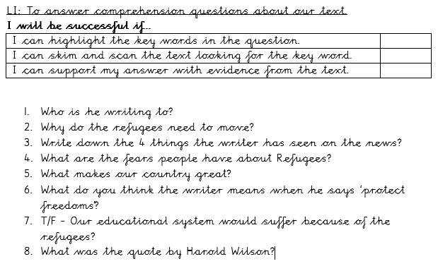
- What was the quote by Harold Wilson?

