LI: To solve problems using Algebra

**I will be successful if…**

|  |  |
| --- | --- |
| I know to look for the parts I can answer first. |  |
| I can use clues to help answer the questions. |  |
| I can show my working out. |  |

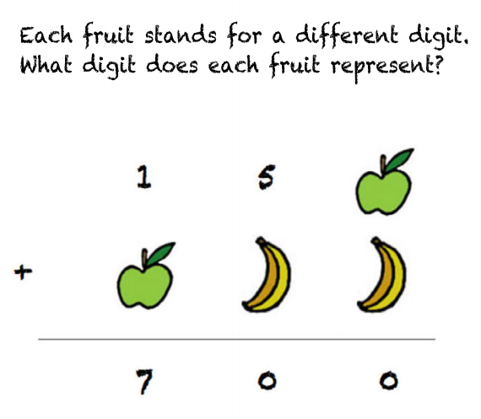

**Step 3:**

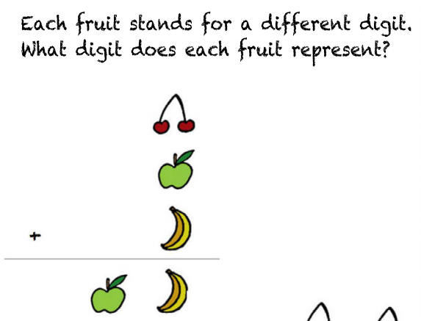

**Step 2:**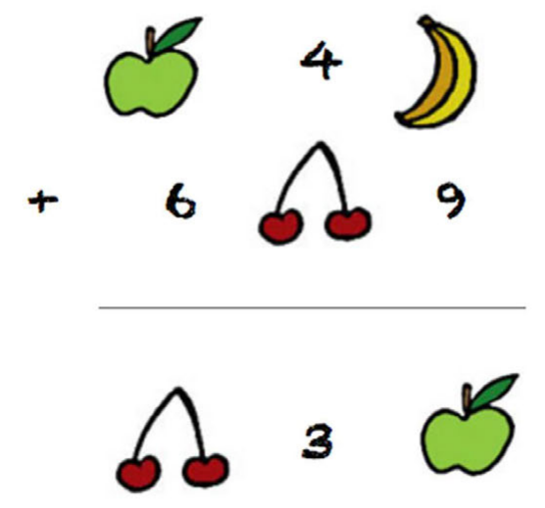

**Challenge 2:**

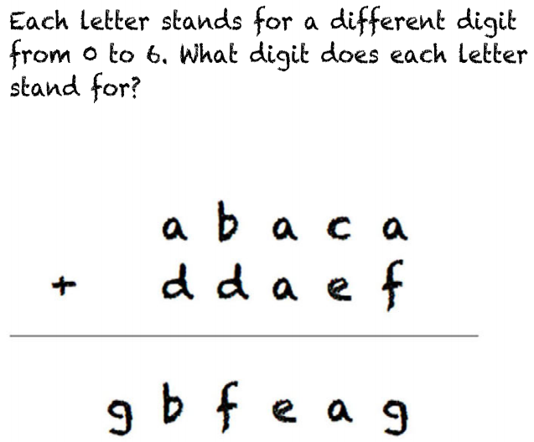

**Challenge 1:**

