LI: To find the place value of each digit of a number.
I will be successful if…
I know my ones, tens, hundred, thousands, tens of thousands and hundreds of thousands.
I can complete a range of question that include place value
I can write a number as a word.
You do...
What is the value of each digit underlined?
562 67,261 782,121 200,328

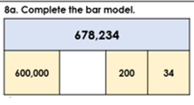
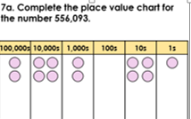

Challenge:
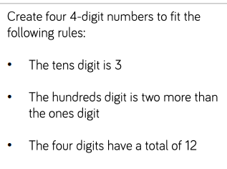
Challenge:
Write these as numbers:
- Three Hundred and Six
- Twenty nine Thousand, Four Hundred and Two
- One hundred thousand, Six Hundred and Thirteen
Write these numbers as words:
- 592
- 12,372
- 568,602

Challenge:
