LI: To find a pattern in a number sequence.

**I will be successful if…**

|  |  |
| --- | --- |
| I can read the question carefully so I know what it is asking for. |  |
| I systematically solve a problem. |  |
| I can show my working out |  |

**Step 1:**

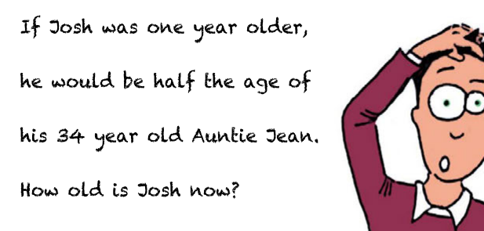

**Step 2:**

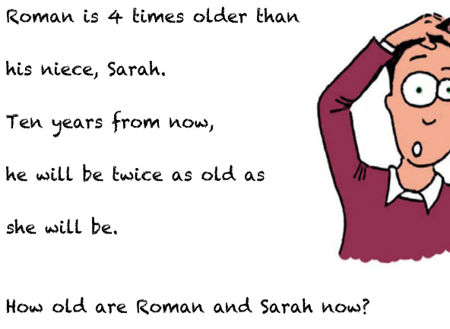

**Step 3:**

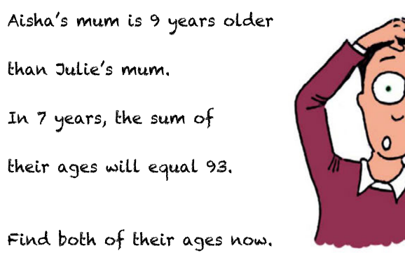

**Challenge 1:**

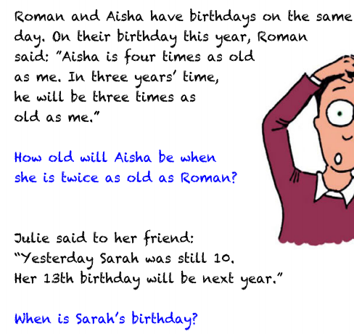

**Challenge 2:**

