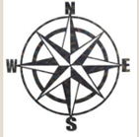

LI: To know what mountains are and how they are formed.

I will be successful if:

|  |  |
| --- | --- |
| I can verbally describe what a mountain is. |  |
| I can locate mount Vesuvius on a map and find out key information about it. |  |
| I can name other mountains and say which continent they are in. |  |

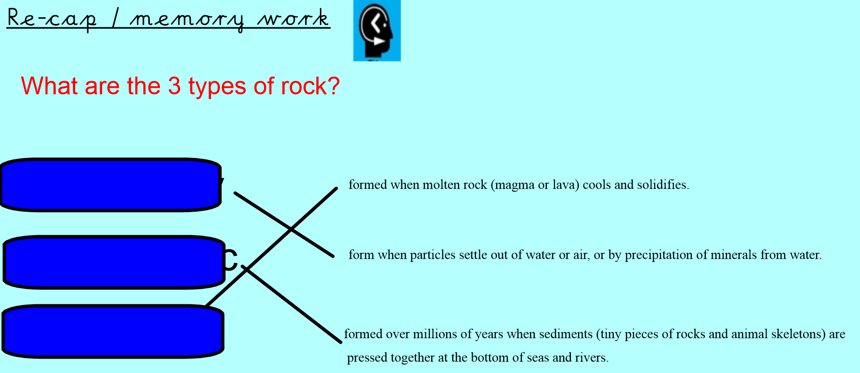

Mount Vesuvius

