L.I:- To be able to recognise the importance of Captain Cook.
I will be successful if..
- I can explain the link between Whitby and Captain Cook.
- I can create a timeline of events.
- I can recall key facts about Captain Cook.

What can you recall about our previous learning about Whitby?

What do you notice about this photograph?
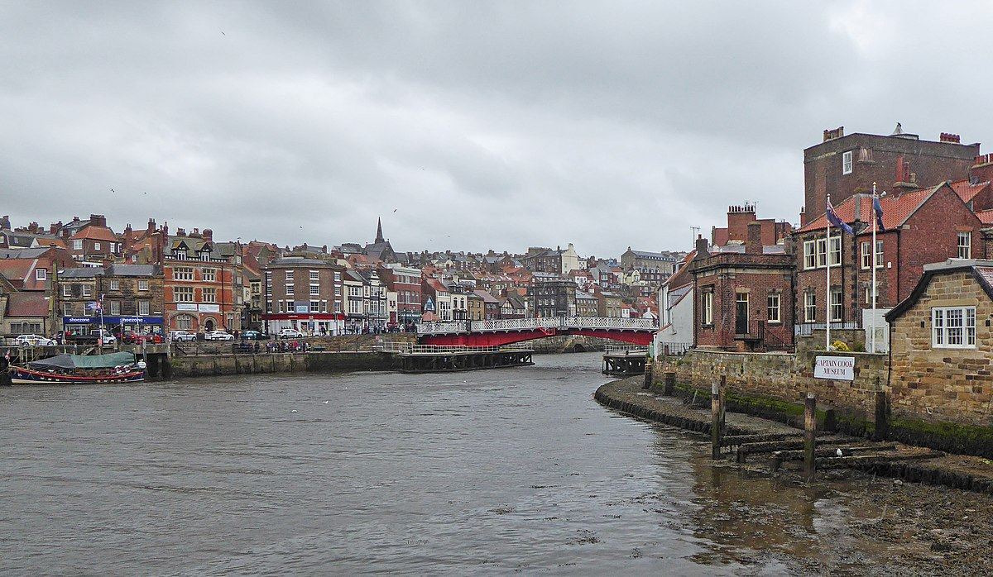
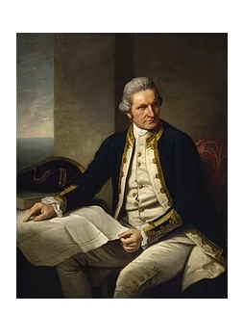
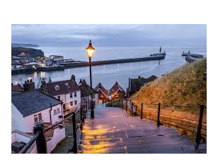
What could be the significance of these images?

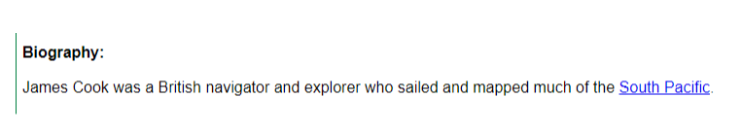
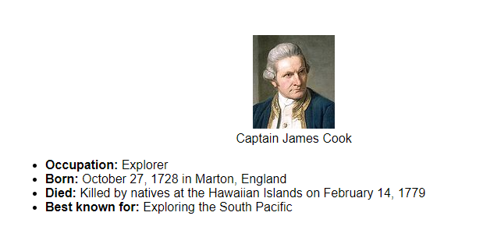

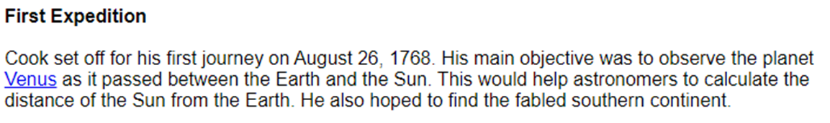
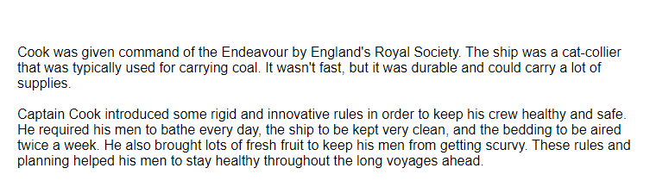
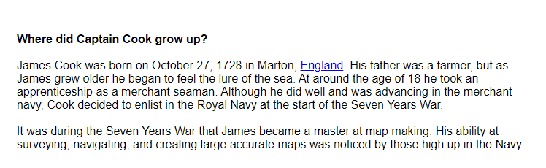

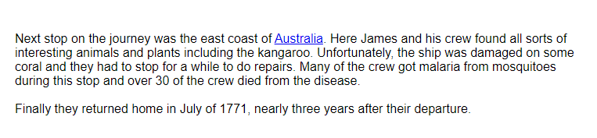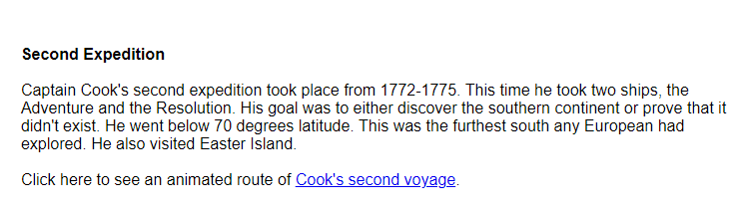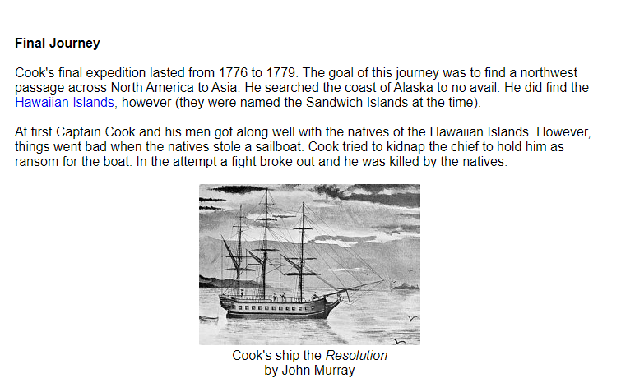
https://www.ducksters.com/biography/explorers/captain_cook_second_voyage.gif
https://www.dkfindout.com/uk/history/explorers/captain-cook/

- Can you create a timeline of events using the information about Captain James Cook?
What will you include and what will you not include in the timeline?

- Can you create a top 5 fun facts ab out Captain Cook to help you recall knowledge for next week?

