24.02.2020

LI: To add and subtract a multiple of ten from a 2-digit number.

|  |  |
| --- | --- |
| I can count on and back in tens |  |
| I can partition numbers into tens and ones |  |
| I can add and subtract a multiple of ten |  |

*Make the amounts using 10p and 1p coins.*

*Add or subtract tens to find the new prices.*



**42p**



**10p less =**



**24p**

**20p more =**



**53p**



**30p less =**

Challenge

Draw your own character key ring. Make a price for it between 10p and 90p

Draw the 10p and 1p coins you need to buy it.

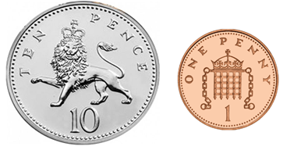

Now find the new prices.

 20p less  20p more

