25.02.2020
LI: To read and write and order numbers to 100.
I can read and write 2 digit numbers
I can partition numbers into tens and ones
I can order numbers to 100

Use these digits to make 2 digit numbers.
Draw each number using tens and ones.

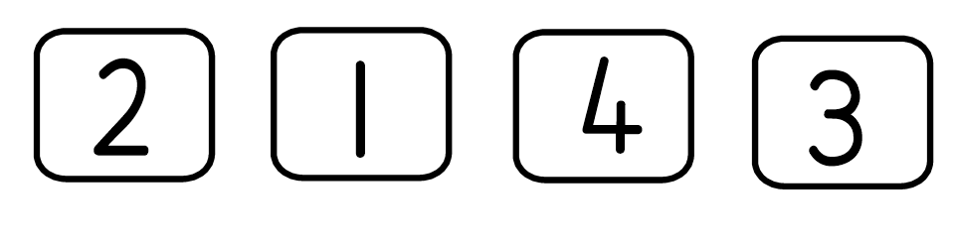
For example:
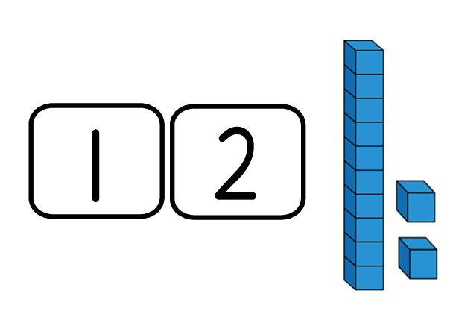

- What is the largest number you can make?
- What is the smallest number you can make?
- Add the 2 smallest numbers together.
- Subtract the smallest number from the largest.
- Put the numbers in order from smallest to largest.

