Monday 8th February
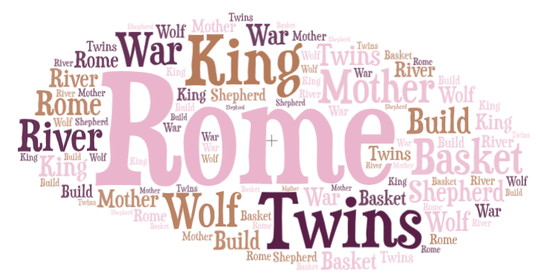
Make a prediction about our new text
Who could our characters be?

Where could it be set?

What could happen?

