Monday 8th February
LI: to be able to identify the features of an information leaflet
Features of an information text
- Eye catching slogan/heading
- Photographs and images
- Short and snappy sentences
- Final reminder
- Interesting layout
I will be successful:
- I can explain what an information text is
- I can recall the features of an information leaflet
- I can identify the features of an information leaflet
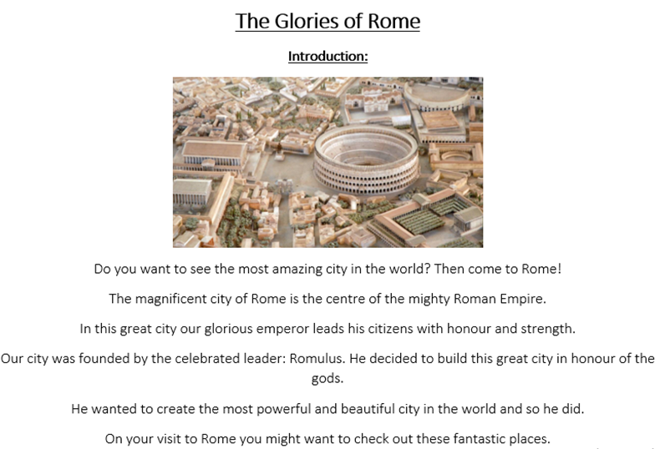
Label the features of an information text
