Monday 8th February 2021– English
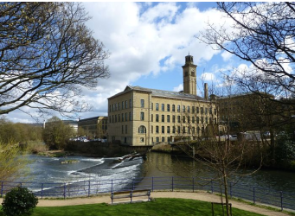
Write a descriptive paragraph about this scene in Saltaire.
How many points can you earn?

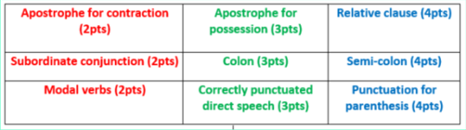

Formal tone

Which of these sentences is written in the formal tone? Edit the other sentence so it is more formal.

Professor van Helsing's a really good doctor and knows loads of stuff about why people get poorly.

It is believed that Lucy has been suffering from a rare form of blood condition, linked to the two small punctures on her neck.

This week, we are going to innovate the newspaper WAGOLL.

We are going to re-read pages 37 – 44 of Dracula.

As we read the pages, think about what the news story could be...

'Mysterious illness strikes!'

'Dutch Doctor to the rescue!'

Let's plan the first sections of our innovated newspaper report...

I can use the existing newspaper report structure to plan.
I can use my knowledge about the text to support the information I include.
I can include and plan the key features of newspaper reports.

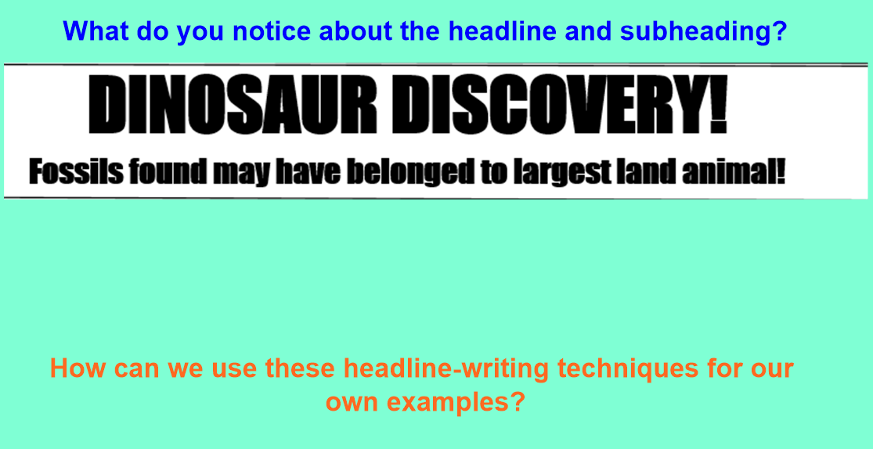

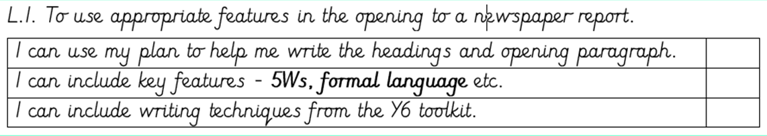
Underlying pattern | Idea for new newspaper report
Headline

Subheading

Opening paragraph – summarises the story, using the 5Ws (who, where, when, what, why) | Who –  Where –  When –  What –  Why –
Detailed paragraph(s) – extra information about the news

Detailed paragraph(s) - quotes from
witnesses

Detailed paragraph(s) summarising the current situation and suggesting what might happen next.

