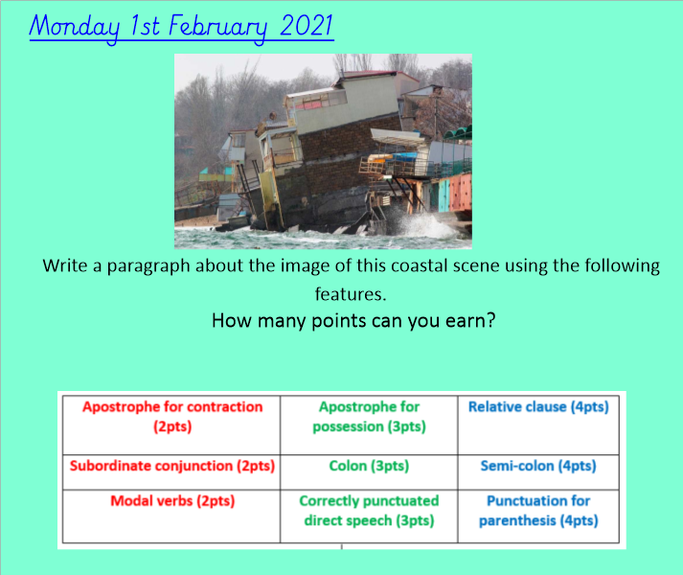

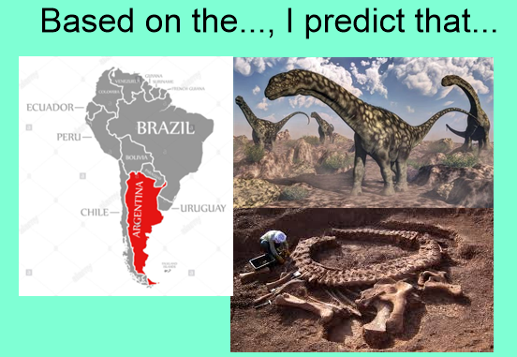
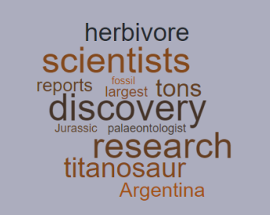
Pick 4 of these words and explain what clues they give us about our new text.

e.g.
The word research hints at __________________________
Argentina suggests that _______________________________

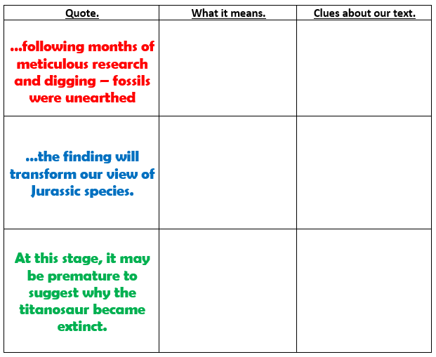
Our new text is a newspaper article, reporting on the fossil discovery from last week.

How will this text differ from the dual-narrative that we have just written?

What is the purpose of newspaper reports?

Which features can you remember for newspaper reports?

Now, read the Dinosaur Discovery newspaper report WAGOLL!

