Monday
L.I:- To be able to convert units of measuring and apply to problem solving.
I will be successful if..
- I can multiply and divide by 10,100,1000.
- I can annotate the question.
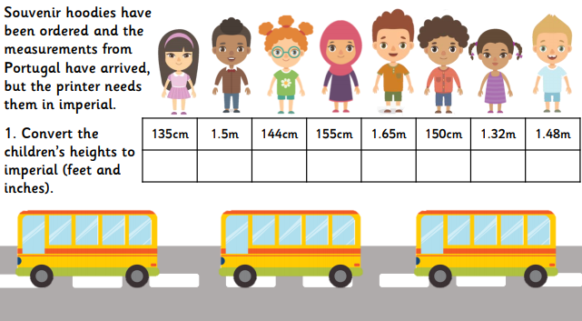
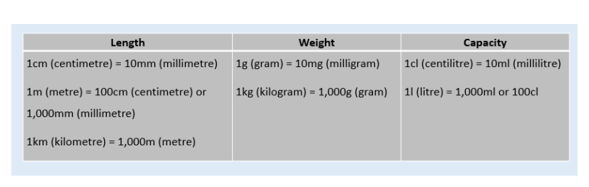
- I can recall key facts.

