Planning Sheet

**Make a plan**

How will you carry out the investigation? Make notes or draw a diagram.

**Make sure it’s fair**

Which one factor will you change each time? (for example the type of material, the number of layers, the area of the material).

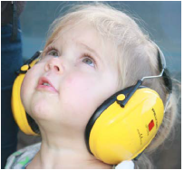

**Make a prediction**

Which do you think will work best?

Explain your reasons.

Why?

**Recording results**

How will you record your results? Draw a results table on the back of this sheet.

**Check your resources**

What will you need for your investigation?