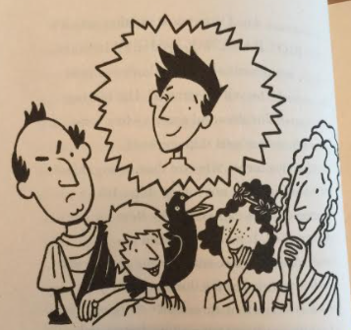
Reading Lesson
Friday 26th February
Pages 3-6
Character Connections
Can you complete the character connections?
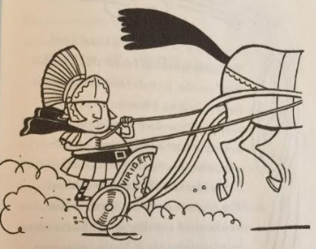
New Green Team Member:

Green Team Leader:

Son:

Daughter:

Pet:

Mum:

Dad:

