Reading Lesson
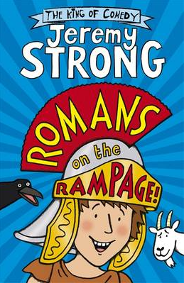
Thursday 25th February
Pages 1-3

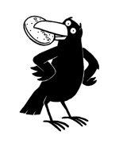

Character Profile
What do we know about the narrator?
Think/look back at the text. Fill in the boxes below.
Things I know for certain about the narrator | Hints and clues I am getting about the narrator

