Tuesday Text
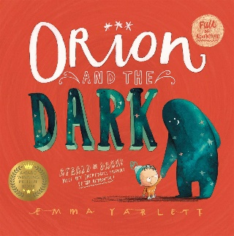

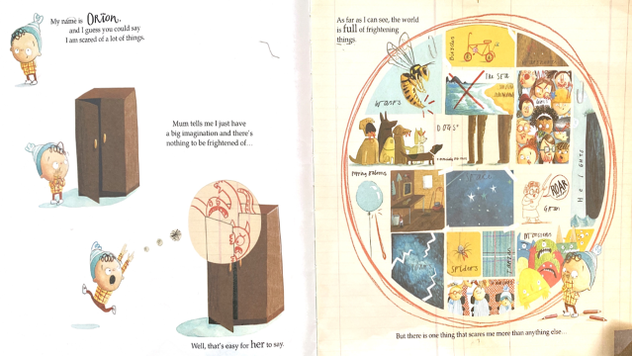
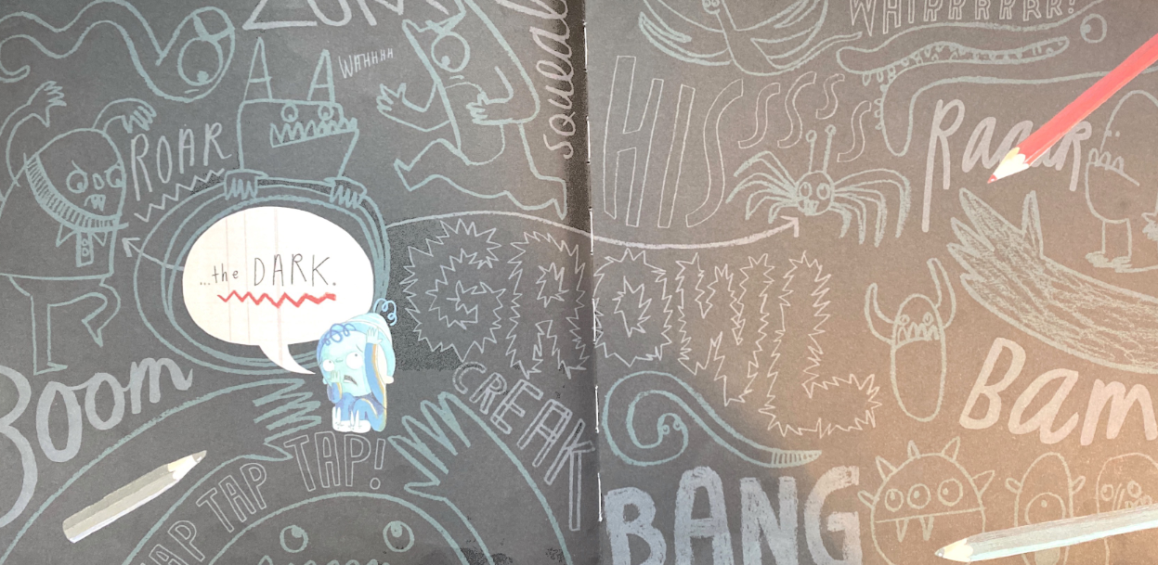

Tuesday 22nd February 2021
1a Draw on knowledge of vocab to understand texts.

Cut out the words in the table below. There ae no correct or incorrect answers today but you must talk about what the words mean and how powerful they are. For example, the words shadow and shady have a similar meaning but you might think one words describes better that the other. The most powerful words should be stuck in the green area of the vocabulary target and the least powerful words in the outer red circle. This activity helps us to think about why authors choose certain words to use in their stories when they want to create a mood or effect.
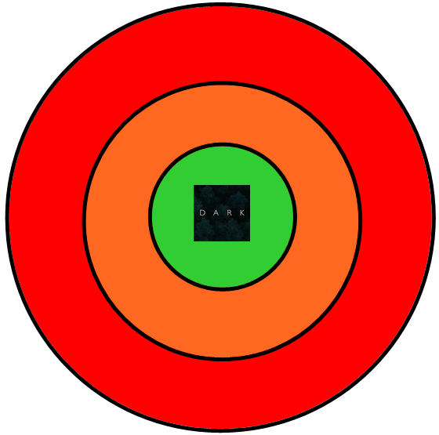
twilight | bright | dim
glowing | dusk | light
dull | afraid | sunny
blackness | shadow | shady

