Reading Text for Wednesday
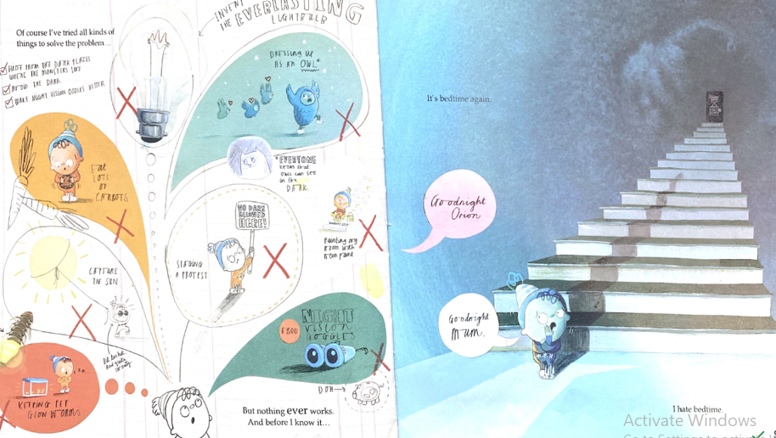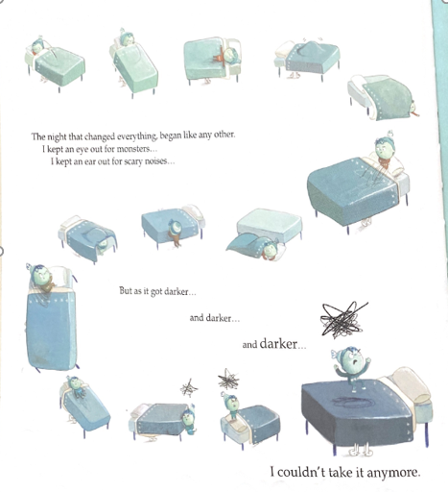

Wednesday 24th February 2021
Content Domain: 1d make inferences from the text
Think about how Orion would be feeling when he goes to bed alone. What might he be saying. Fill in the speech bubble or write below what you think Orion should say to make the dark go away.




