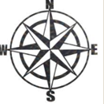
LI: To learn about the features of the River Aire

Success Criteria: | TA
I know what mouth, source and confluence mean.
I can research using IPads to fill in a table.
I can write about the River Aire using the information I have learnt.

Brain Dump - Tell me everything you know about where Saltaire is and how it has changed over the last 300 years.

Question | Answer
Where is the source of the River Aire?
Where is the mouth of the River Aire?
What river does it confluence with?

How long is the River Aire?
What major Cities or Towns does the River Aire pass?
Which sea does the River Aire eventually go into?

