Year 1 and 2 R.E. – Salvation Week 1.
Our new big question is:
Why does Easter Matter to Christians?

Can you name these foods and explain when Christians might eat them?
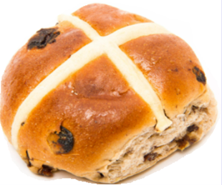

Are these foods what makes Easter special for Christians?
Find out about Easter by watching this video
https://www.youtube.com/watch?v=Wnbo2AmS3OI

What picture might Christians put on the front of the lunchbox to show people what is more special at Easter than the food?

