Thursday 11th February
LI: To recognise and find fractions of shapes and amounts.
I will be successful if:
I can remember that fraction have equal parts.
I know that the denominator tells me how many parts there are.
I can eliminate things it can’t be.

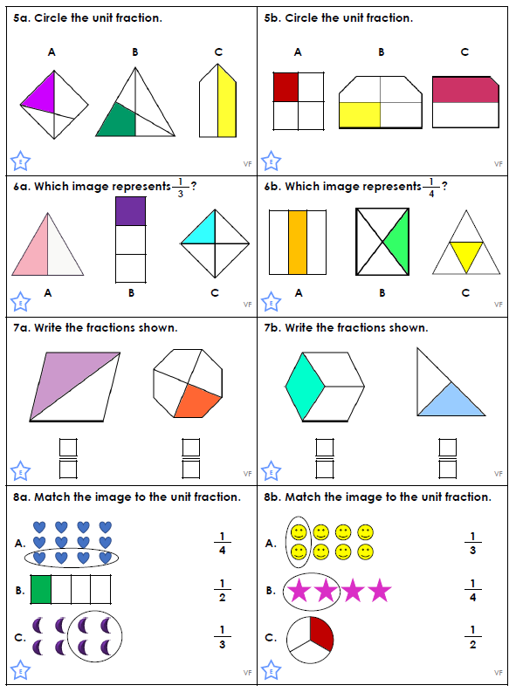

Challenge
