Wednesday 10th February
Li: to be able to write a descriptive information section for an information leaflet
I will be successful if:
- I can recall key information
- I can use coordinating conjunctions
- I can use adjectives
- I can use question marks
The Forum
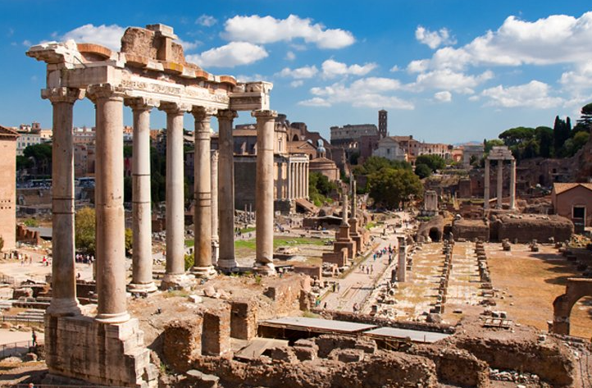
Visit the very centre of Rome. In this place you will be at the heart of government, law and business.
This is this place where the fate of the Empire was decided. Rules and laws were created here and passed onto the rest of the world.
Not only would you come here to make history. You would come to the Forum to enjoy the bustling and busy markets.
In these colourful markets stall you can buy everything you need and want from fish to fabric.
Whilst here why not say a pray to our wonderful gods? You could visit one of the many temples and leave a gift for your favourite god.
Rewrite The Forum section in your own words
_______________________________________________________________________________________
_______________________________________________________________________________________
_______________________________________________________________________________________
_______________________________________________________________________________________
_______________________________________________________________________________________
_______________________________________________________________________________________
_______________________________________________________________________________________
_______________________________________________________________________________________
_______________________________________________________________________________________
_______________________________________________________________________________________
______________________________________________________________________________________

