Wednesday 10th February
Li: to be able to write a descriptive information section for an information leaflet
I will be successful if:
- I can recall key information
- I can use coordinating conjunctions
- I can use adjectives
- I can use question marks
Overwrite: rewrite each line in your own words.
The Forum
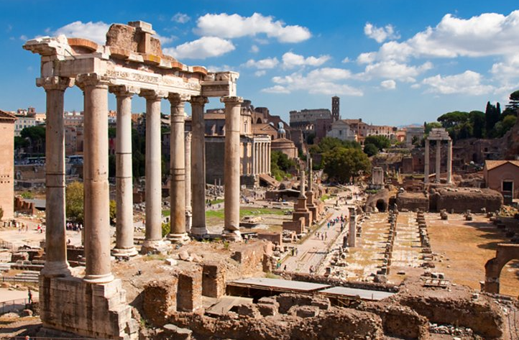
Visit the very centre of Rome. In this place you will be at the heart of government, law and business.
_______________________________________________________________________________________
This is this place where the fate of the Empire was decided. Rules and laws were created here and passed onto the rest of the world.
_______________________________________________________________________________________
Not only would you come here to make history. You would come to the Forum to enjoy the bustling and busy markets.
_______________________________________________________________________________________
In these colourful markets stall you can buy everything you need and want from fish to fabric.
_______________________________________________________________________________________
Whilst here why not say a pray to our wonderful gods? You could visit one of the many temples and leave a gift for your favourite god.
_______________________________________________________________________________________

