Thursday 4th February 2021

Write down as many rules as you can remember about formal language.

The introductory paragraph in a newspaper report needs to include...

5 Ws
Who
What
Where
When
Why

Re-read the WAGOLL – what are the 5Ws?

L.I. To include appropriate features in a newspaper introductory paragraph.
I can include the 5Ws.
I can choose and include only the most important information.
I can use a formal tone throughout.

Let's label this image with the 5Ws, before we write our formal introductory paragraph.

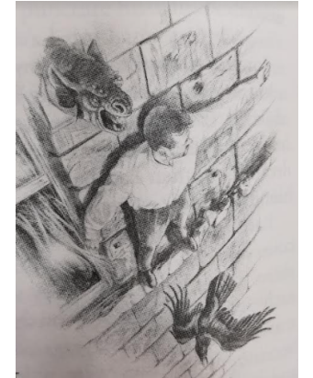

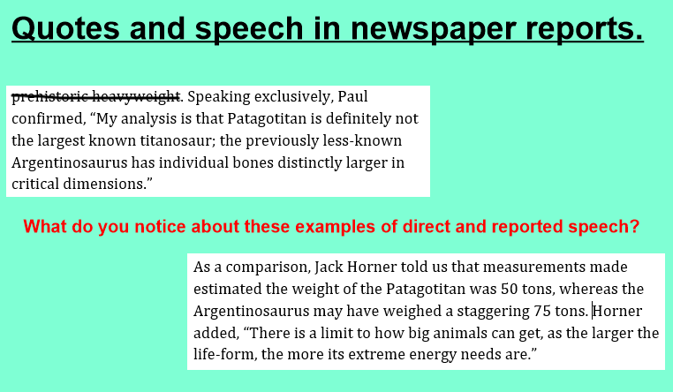

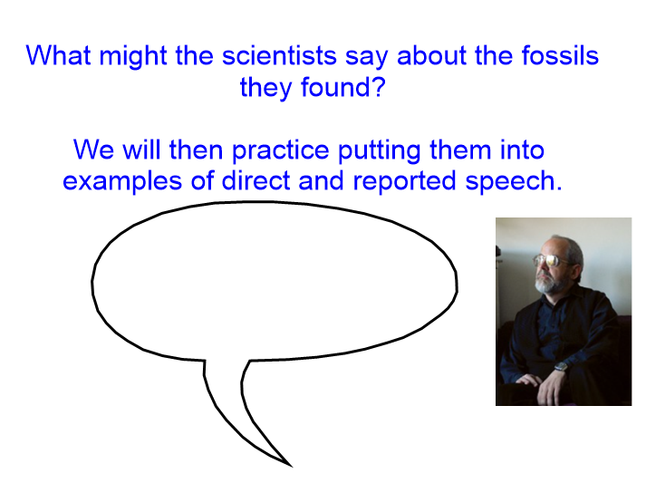

Now, use your ideas to write it in a formal paragraph. Use at least one example as direct speech and one example as reported speech.
