Tuesday 23rd ^{th} February 2021
LI: To be able to learn new vocabulary and understand their meaning.
I am able to know the word class of new learnt vocabulary.
I am able to match the word to its picture (definition)

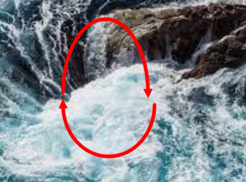
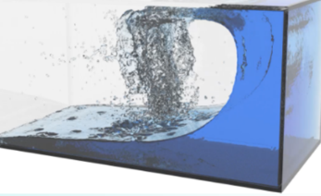
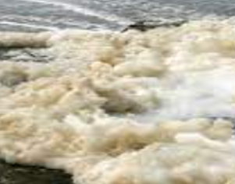
Match the word to the picture?
sloshing
swizzle
spume

Are you able to fill in the blank so the sentence makes sense?
George watched the water.
Fume and boiled in the pan.

