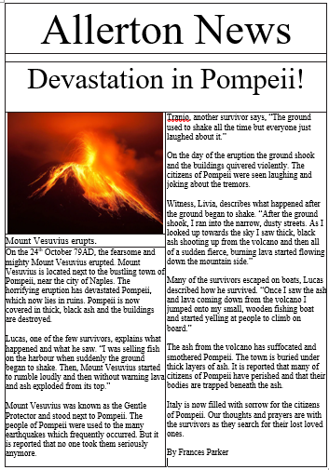

**LI: to be able to know the features of a newspaper**

**I will be successful if:**

* I can recall the features
* I can identify the features