Monday 8th February
Li: to be able to write an introduction to an information leaflet
I will be successful if:
- I can recall key information
- I can use coordinating conjunctions
- I can use adjectives
Introduction
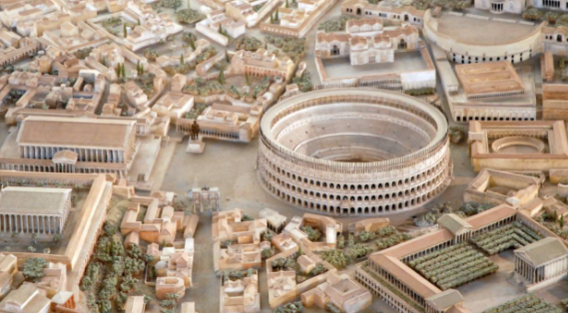
Do you want to see the most amazing city in the world? Then come to Rome!
The magnificent city of Rome is the centre of the mighty Roman Empire.
In this great city our glorious emperor leads his citizens with honour and strength.
Our city was founded by the celebrated leader: Romulus. He decided to build this great city in honour of the gods.
He wanted to create the most powerful and beautiful city in the world and so he did.
On your visit to Rome you might want to check out these fantastic places.

Rewrite the introduction in your own words.
__________________________________________________________________________________________________________________________________________________________________________________________________________________________________________________________________________________________________________________________________________________________________________________________________________________________________________________________________________________________________________________________________________________________________________________________________________________________________________________________________________________________________________________________________________________________________________________________________________________________________________________________________________________________________________________________________________________________________________________________________________________________________________________________________________________________

