Tuesday 9th February
LI: To find unit and non-unit fractions of shapes.
I will be successful if:
I can count how many parts there are in the whole shape.
I can find the fraction of the amount by dividing by the denominator and multiplying by the numerator.
I can shade the correct number of parts on the shape.
1.
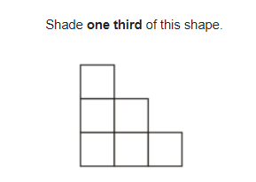
2. 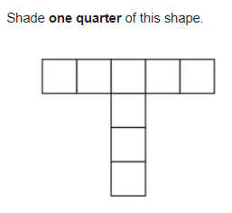

3. Shade $\frac{1}{3}of this shape$
5. Shade $\frac{3}{4}of this shape$
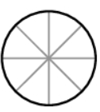
4. Shade $\frac{3}{5}of this shape$
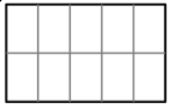

True/ false/ prove it
1.
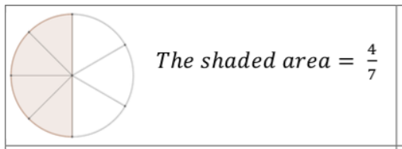

2. $\frac{1}{2}of this shape is shaded.$

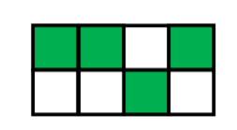
3. 