Monday 8th February
Li: to be able to write an introduction to an information leaflet
I will be successful if:
- I can recall key information
- I can use coordinating conjunctions
- I can use adjectives
Overwrite: take each line and rewrite it in your own words.
Introduction
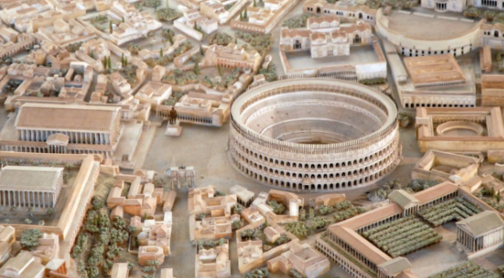
Do you want to see the most amazing city in the world? Then come to Rome!
_______________________________________________________________________________________
The magnificent city of Rome is the centre of the mighty Roman Empire.
_______________________________________________________________________________________
In this great city our glorious emperor leads his citizens with honour and strength.
_______________________________________________________________________________________
Our city was founded by the celebrated leader: Romulus. He decided to build this great city in honour of the gods.
_______________________________________________________________________________________
He wanted to create the most powerful and beautiful city in the world and so he did.
_______________________________________________________________________________________
On your visit to Rome you might want to check out these fantastic places.
_______________________________________________________________________________________

