Tuesday 9th February 2021– English
Embedded clause
An embedded clause includes a relative pronoun and is in the middle of a sentence.

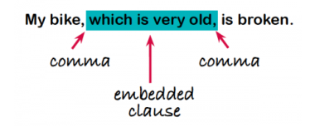
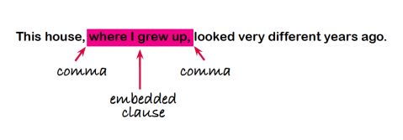

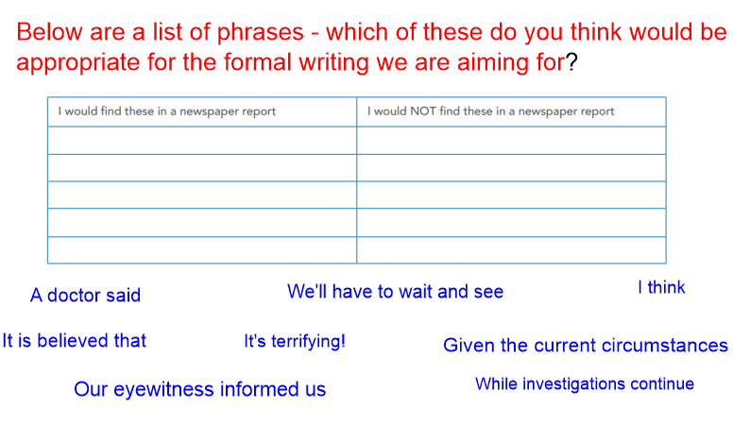

Let's add to our plans from yesterday, as we prepare to write the detailed paragraphs of our newspaper report...

Remember to join live learning to do this alongside the teachers!

Who are the expert witnesses?
What might they say about the situation?
Think about the tone that they would use.

Now, use the WAGOLL and/or Overwrite sheets to help you write these next paragraphs for your Dracula-inspired newspaper report.

