Tuesday 2nd February 2021
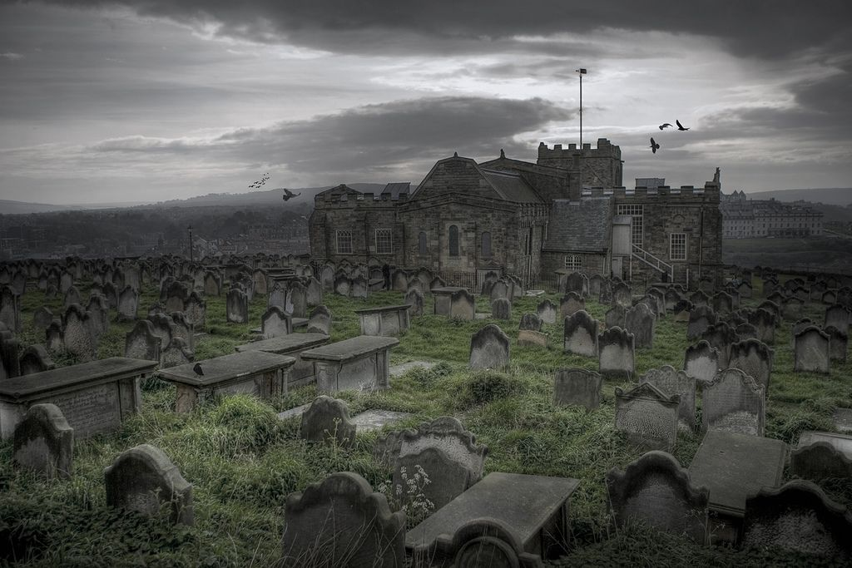
Write a paragraph about the graveyard in Whitby using the following features.
How many points can you earn?
Apostrophe for contraction (2pts) | Apostrophe for possession (3pts) | Relative clause (4pts)
Subordinate conjunction (2pts) | Colon (3pts) | Semi-colon (4pts)
Modal verbs (2pts) | Correctly punctuated direct speech (3pts) | Punctuation for parenthesis (4pts)

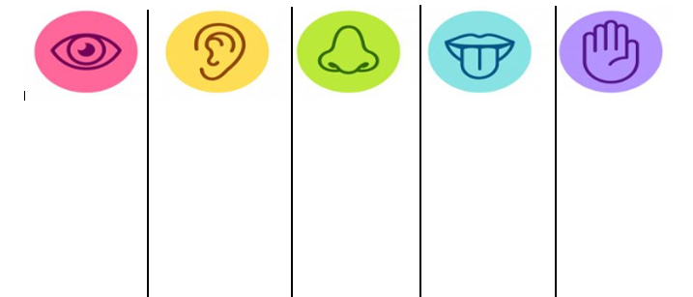
LI: To retrieve information from the text.
I can find key information in the text.
I can skim, scan and trap information,
I can explain my answers, using the evidence in the text.

On which date were fossils discovered? _________________________________

How long did it take for the palaeontologists to discover the fossils? __________

Where were the fossils discovered? Provide two pieces of information from the texts:
- ______________________________________
- ______________________________________
Read paragraph 2. Find and copy the verb, which suggests T-Rex is small in comparison to the Argentinosaurus.
___________________________________________________________

Which phrase gives the impression that the dinosaur fossils are incomplete?
_________________________________________________________________

True or False?
Prove the statement is true or false, by copying key information from the text.
 | True | False | Evidence
Dr Paul says it could be argued the Patagotitan is larger than the Argentinosaurus.

Three-dimensional reproductions of the dinosaur were created.

Argentinosaurus became extinct because it was killed by predators.

In the second column of the newspaper article, it informs the reader about the dinosaur’s characteristics. Write in the table whether those features were strengths or weaknesses for the Argentinosaurus. Be prepared to explain why!

Strengths | Weaknesses

‘Dr Gregory Paul is more interested in the research than that the Argentinosaurus fossil is from the largest dinosaur ever found’.
Do you agree with this statement?

Tick one.

Yes
No
Maybe
Explain your choice fully, using evidence from the text.
____________________________________________________________________________________
____________________________________________________________________________________
____________________________________________________________________________________
____________________________________________________________________________________
____________________________________________________________________________________
____________________________________________________________________________________
_____________________________________________________________________________________

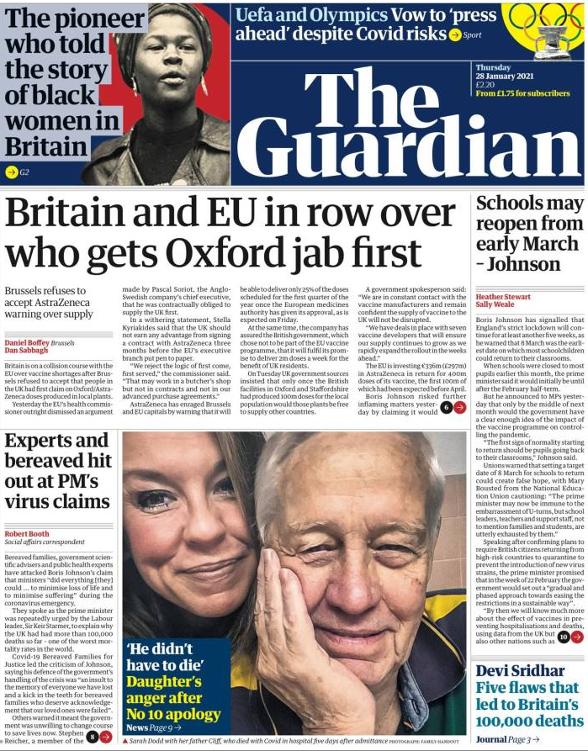

Label the newspaper features, either on the front cover in your pack, or on an appropriate newspaper that you have at home.

newspaper name image

detailed paragraphs price

headline subheading

by-line past tense

introduction – 5 Ws caption

columns facts opinions

