Monday – Hook day Activities
Make a volcano out of junk

Use a plastic bottle. 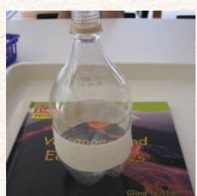
Then either:
make a cardboard or paper cone to go around/over it.
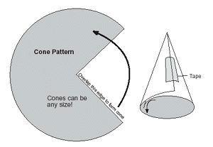
or
wrap folded strips of newspaper round it (You can paper mache on top of that if you like)
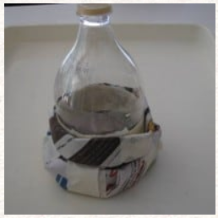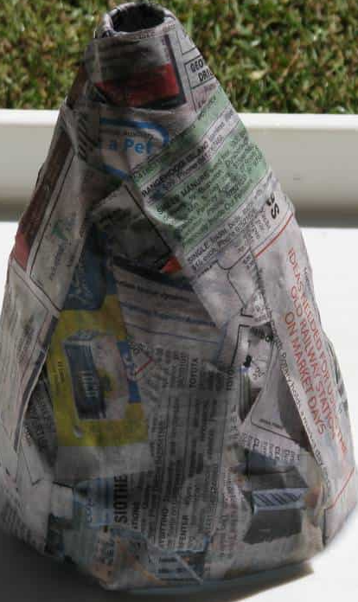
Then paint it (If you want to and have some paints)

To erupt your volcano:
- 1 tbsp bicarbonate of soda (baking soda)
- 1 tbsp washing up liquid.
- 2 tbsp water.
- ½ cup vinegar.
- 1 tbsp red food colouring.

6. In a bowl, combine the bicarbonate of soda and washing up liquid. Add the water and mix thoroughly. Pour this mixture into your volcano.
7. In a cup, mix together the vinegar and food colouring.
8. When you're ready, pour the vinegar into the bottle with the bicarbonate. Wait for it to erupt and watch how the lava flows.

