Allerton News
Devastation in Pompeii!
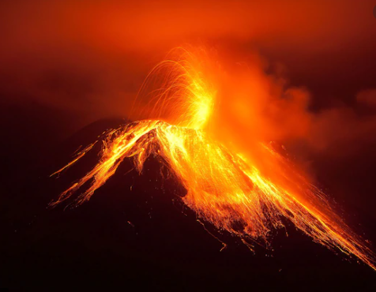 | Tranio, another survivor says, “The ground used to shake all the time but everyone just laughed about it.”  On the day of the eruption the ground shook and the buildings quivered violently. The citizens of Pompeii were seen laughing and joking about the tremors.  Witness, Livia, describes what happened after the ground began to shake. “After the ground shook, I ran into the narrow, dusty streets because I was scared. As I looked up towards the sky I saw thick, black ash shooting up from the volcano and then all of a sudden fierce, burning lava started flowing down the mountain side.”  Many of the survivors escaped on boats, Lucas described how he survived. “Once I saw the ash and lava coming down from the volcano I jumped onto my small, wooden fishing boat and started yelling at people to climb on board because I knew that if we didn’t leave we would die.”  The ash from the volcano has suffocated and smothered Pompeii. The town is buried under thick layers of ash. It is reported that many of citizens of Pompeii have perished and that their bodies are trapped beneath the ash.  Italy is now filled with sorrow for the citizens of Pompeii. Our thoughts and prayers are with the survivors as they search for their lost loved ones.  By Frances Parker
Mount Vesuvius erupts.
On the 24th October 79AD, the fearsome and mighty Mount Vesuvius erupted. Mount Vesuvius is located next to the bustling town of Pompeii, near the city of Naples. The horrifying eruption has devastated Pompeii, which now lies in ruins. Pompeii is now covered in thick, black ash and the buildings are destroyed.

Lucas, one of the few survivors, explains what happened and what he saw. “I was selling fish on the harbour when suddenly the ground began to shake. Then, Mount Vesuvius started to rumble loudly and then without warning lava and ash exploded from its top.”

Mount Vesuvius was known as the Gentle Protector and stood next to Pompeii. The people of Pompeii were used to the many earthquakes which frequently occurred. But it is reported that no one took them seriously anymore.

