Wednesday 10th February
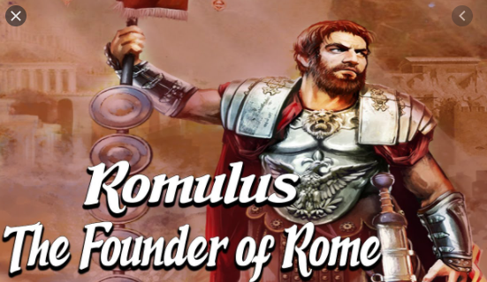

Character Profile
What do we know about Romulus?
Think/look back at the text. Fill in the boxes below.
Things I know for certain about Romulus | Hints and clues I am getting about Romulus

