Wednesday 10th February
LI: To find half, quarter or third of an amount by sharing.
I will be successful if:
I can draw the correct number of counters.
I can share the counters out in to the right number of groups.
I can count the objects in one group.

find these fractions of amounts.
e.g. find $\frac{1}{2}$ of 18
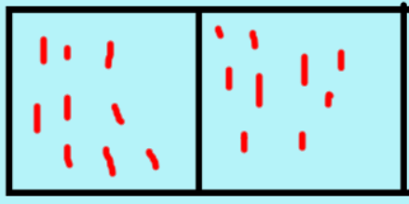
Share them into 2 groups. Count how many in one group. $\frac{1}{2}$ of 18 = 9

1. $\frac{1}{2}of 16=$
$$2. \frac{1}{3}of 15=$$
3. $\frac{1}{4}$ of 24 =
4. $\frac{1}{3}of 21=$
5. $\frac{1}{4}of 32=$
6. ½ of 20 =
7. $\frac{1}{4}of 40=$
8. $\frac{1}{3}of 27=$

