Tuesday 9th February
Li: to be able to write a descriptive information section for an information leaflet
I will be successful if:
- I can recall key information
- I can use coordinating conjunctions
- I can use adjectives
The Colosseum
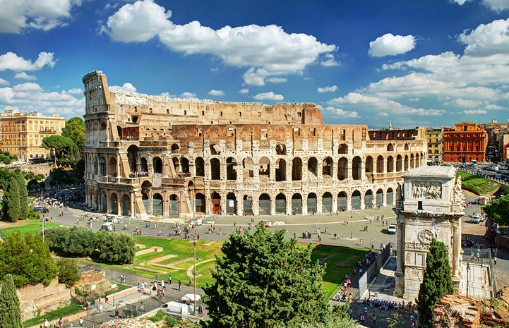
Welcome to the Empire’s biggest and best amphitheatre. This colossal building can seat 50,000 people.
Come and watch the fearsome and vicious gladiators battle to the death. Who will win?
Will it be the heavily armoured Provocator with his deadly sword?
Or will it be the quick and nimble Retiarius with his net and spear?
You may even get to see wild and exotic animals from across the Empire challenge these fierce fighters.
In this blood covered arena you will be entertained and thrilled by the battles which take place and best off all it is free!

Rewrite The Colosseum section in your own words.
__________________________________________________________________________________________________________________________________________________________________________________________________________________________________________________________________________________________________________________________________________________________________________________________________________________________________________________________________________________________________________________________________________________________________________________________________________________________________________________________________________________________________________________________________________________________________________________________________________________________________________________________________________________________________________________________________________________________________________________________________________________________________________________________________________________________

