Wednesday 10th February

After the live lesson today, or watching the loom video, have a go at the following Mymaths activity.
https://app.mymaths.co.uk/1772-lesson/introducing-equivalent-fractions
Use the QR code to access the right mymaths activity or follow the following instructions:
- search mymaths and log in with stjames8 square204
- click number, fractions, Y4 introducing equivalent fractions
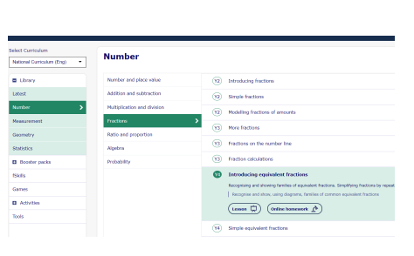
After that, if you know your own personal log in for mymaths, log in to the portal and complete the fraction homework. If you need your log in, please ask.

