Tuesday 9th February
Li: to be able to write a descriptive information section for an information leaflet
I will be successful if:
- I can recall key information
- I can use coordinating conjunctions
- I can use adjectives
Overwrite: rewrite each line in your own words.
The Colosseum
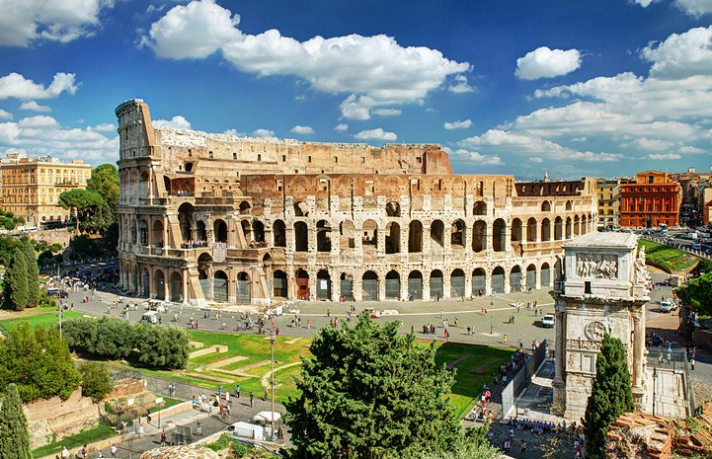
Welcome to the Empire’s biggest and best amphitheatre. This colossal building can seat 50,000 people.
____________________________________________________________________________________
Come and watch the fearsome and vicious gladiators battle to the death. Who will win?
_____________________________________________________________________________________
Will it be the heavily armoured Provocator with his deadly sword?
_____________________________________________________________________________________
Or will it be the quick and nimble Retiarius with his net and spear?
______________________________________________________________________________________
You may even get to see wild and exotic animals from across the Empire challenge these fierce fighters.
_____________________________________________________________________________________
In this blood covered arena you will be entertained and thrilled by the battles which take place and best off all it is free!
_______________________________________________________________________________________

