Wednesday 24th February 2021- English

Before the lesson, please cut the poem up line by line! (Don’t let your child see the poem before hand)
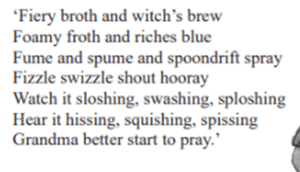
Then please try and put the poem back together again! What do you notice and why? Are there any rhyming couplets? What do you think our new poem is about?

