LI: To construct predictions about a poem using modal verbs and conjunctions.

Picture Prediction
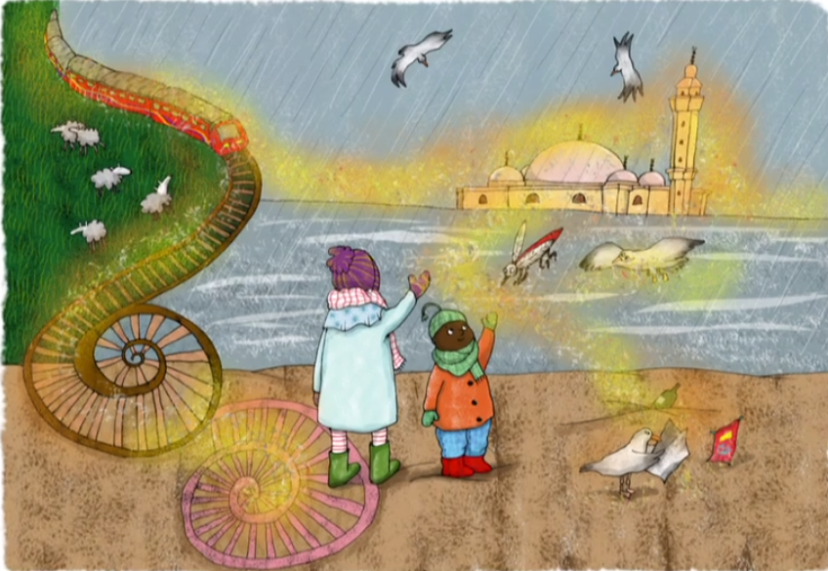
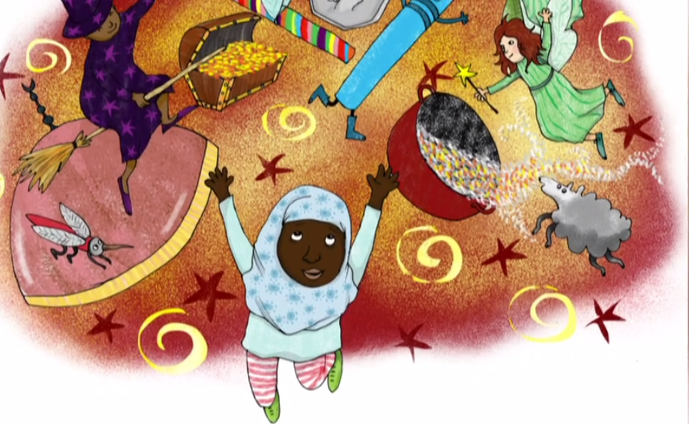
Use the pictures below to make a prediction of what our poem is going to be about. Make sure to use modal verbs and conjunctions.
Subordinating Conjunctions
since
because
as
although
when
Modal Verbs
may
might
could
should
will

Now have a look at the word cloud. Do your thoughts stay the same or change? Think about how the poem may link to the theme we have been looking at in the Spring term.
