Wednesday 3rd February 2021
Re-read the newspaper WAGOLL.
Think about which questions you might ask the palaeontologist, Dr Paul, and (being creative!) the Argentinosaurus.

My Question:____________________________________
________________________________________________________________________________________________
Dr Gregory Paul’s Answer: ________________________
________________________________________________________________________________________________________________________________________________________________________________________________

My Question:____________________________________
________________________________________________________________________________________________
Argentinosaurus answer: _________________________
________________________________________________________________________________________________________________________________________________________________________________________________
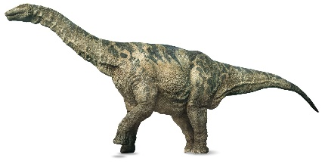

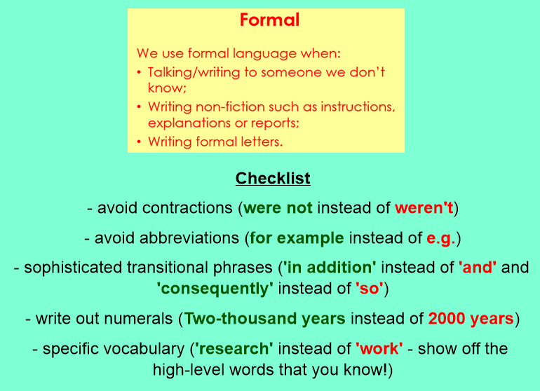
Now, convert these informal paragraphs into more formal language, using the checklist to help you.

Loads of years ago, there were 2 groups of people living in Ancient Greece. 1 of the groups was called the Spartans, and they’d fight with anyone who’d attack them e.g. Athenians, which was the name of the other group. The Athenians weren’t as happy to fight but also wanted to be the strongest gang. People think Athenians were nicer to people, but they didn’t always let people do what they wanted e.g. women couldn’t vote.

