R.E. – Week 1

People find it impossible to be both religious and scientists.

Thinking back to our unit before half term, do you agree with this statement?

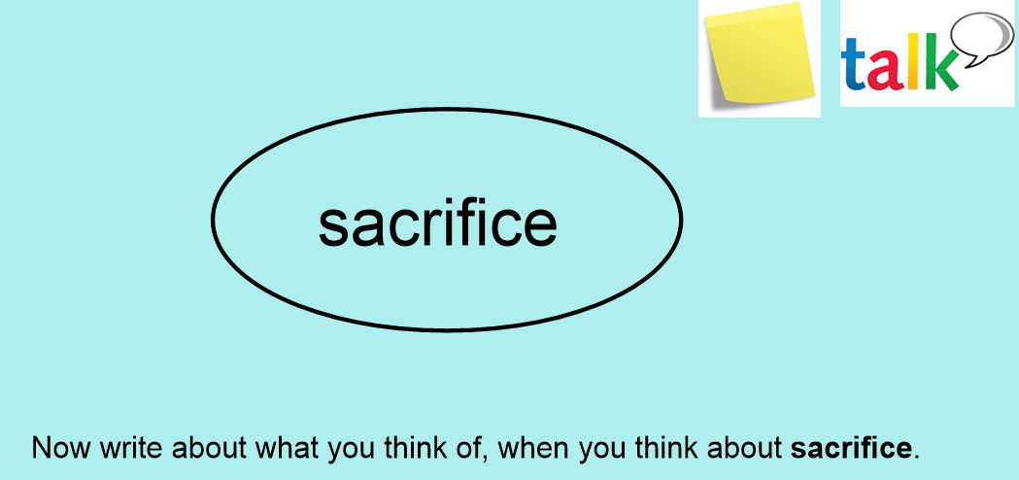

We have learnt about a number of different sections of the Bible's 'Big Story'.

Can you match the appropriate image with the correct heading?
Can you order the images in the correct chronological sequence?

L.I. To understand where the Resurrection fits in the ‘Big Story’ of the Bible.
I can discuss and sequence the key events of the ‘Big Story’.
I can sequence the Easter story chronologically.
I can explain what the Resurrection is.

Our new unit is...
Salvation

What difference does the Resurrection make for Christians?

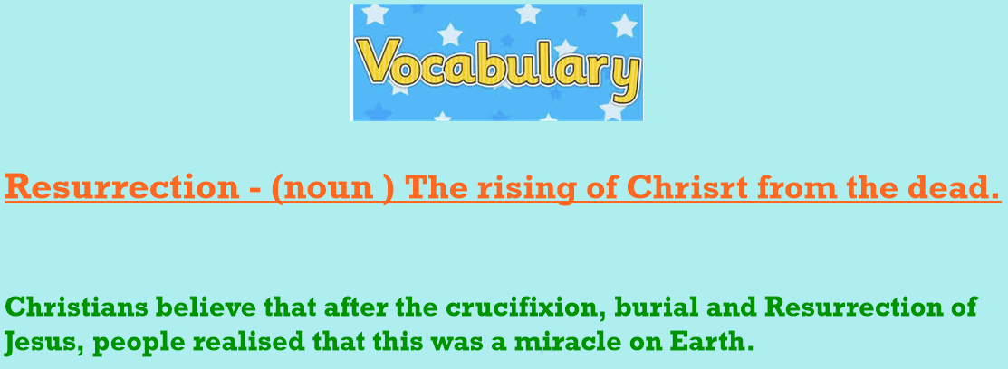

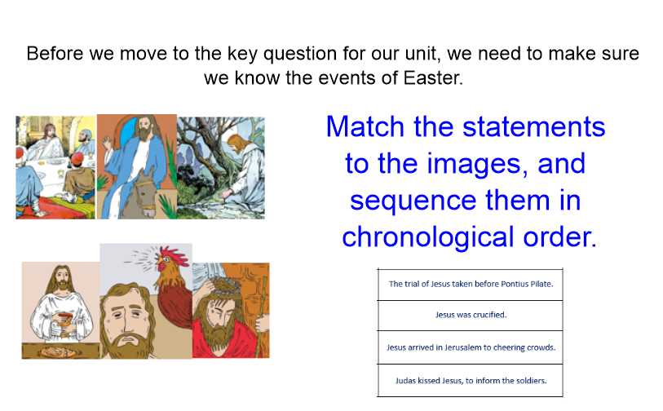
After sequencing, add what details you know about each of these events.

