R.E. – Week 4

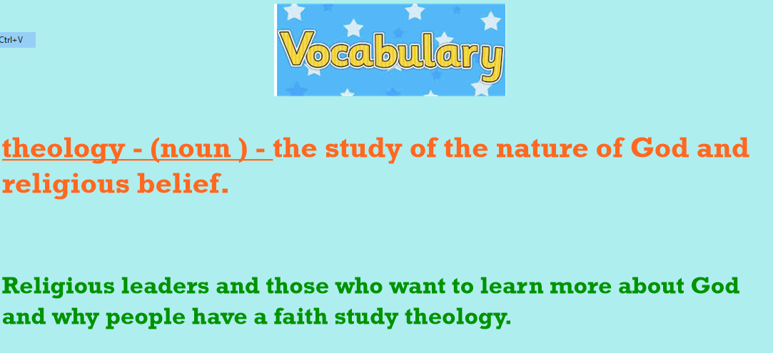

L.I. To explain the role and challenges of God in the lives of scientists.
I can research scientists and understand their reasons for having a faith.
I can comment on how religion impacts on how they live their lives.
I can discuss and explain the challenges scientists face with their faiths.

Astronomer talks faith and life on other planets
Dr Jennifer Wiseman says stars give her a sense of humility and excitement  It is a widely held belief that God created the Earth and all the life in it, but did he also create alien life?  That's one question being asked of eminent astronomer, Dr Jennifer Wiseman, the guest speaker at a Faraday Institute lecture in Cambridge. The scientist also spoke about how her work and personal faith complement, rather than contradict, each other.  Dr Wiseman said; "I think of science as a gift of God to help us understand how nature works in all its intricacies."  Dr Wiseman is a senior scientist working with the Hubble Space Telescope, and she is also the director of a group of scientists promoting positive discussion about faith and science.  In a lecture on Tuesday, 1 March 2011 Dr Wiseman discussed the discovery of hundreds of planets outside our solar system.  Her colleagues at NASA are searching for signs of life elsewhere and she described that search as more exciting now that so many other planets have been detected. "It wouldn't surprise me one bit if we found a universe teeming with life," she said.  Science and faith  Her work currently involves studying how stars are formed and looking at some of the earliest galaxies which were born over 13 billion years ago.  Talking about her work she said: "It's a tremendous privilege and a humbling one. I think it should give us, whatever one's religious perspective, a sense of humility and excitement."  The Faraday Institute encourages discussions of science and religion.  In her lecture, Dr Wiseman questioned what the discovery of other life forms would mean for us as humans, and how people of faith might see God differently.  The Hubble Space Telescope looks at stars formed over 13 billion years ago  Asked whether science and faith contradict each other, she described her own love of science, and her sense of it, as a God-given tool to understand nature.  She added that while science answered the 'how things happen in nature' question, religion answered the broader 'why are we here' and 'what is our purpose' questions.  Reflecting on the magnificence of the universe, Dr Wiseman said: "I believe that God is concerned with the small, the individual.  "He cares about us but is also concerned with the vast times and distances that we have trouble comprehending in our human mind." | It wouldn't surprise me one bit if we found a universe teeming with life  Dr Jennifer Wiseman  