PSHE Week Six – Keeping safe, managing behaviour and risk

Bystander – Someone who witnesses bullying, either in person or online, is a bystander. A bystander is somebody who is present when bullying is happening but not joining in.

Label the roles the children have in this picture:

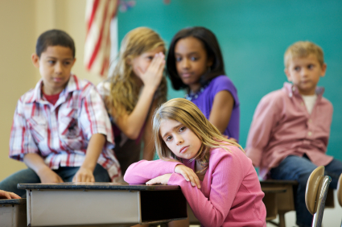

bystander | bully | victim

What should the bystanders do? Make a list.
What is the easiest thing to do? | What is the hardest thing to do?

