Maths
Tuesday 23rd February 2021
Today you will continue to develop your mental math strategies by learning about ‘counting on’ (see the poster below)
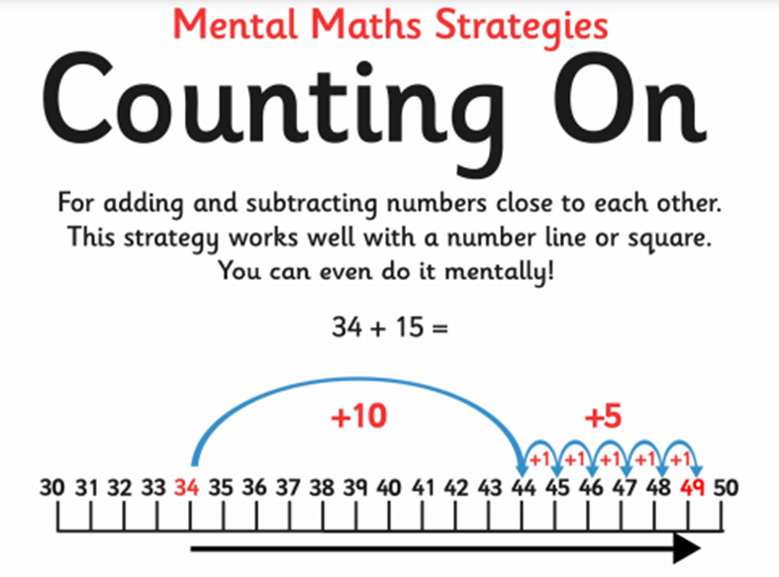
Please answer the questions below and show your working out.
