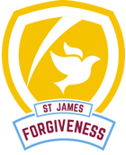
Year 6 Newsletter
Values
In the build up to Easter, our core values for next half term will be Forgiveness.
Please talk to your children about this value:
E.g. What does it mean? How you can show it? Why is it important? How can forgiveness help us?
5 ways of being
We are continuing to celebrate and develop our 5 ways of being in school. Each week children are celebrated and acknowledged for their ability to show the 5 ways of being.
Curriculum
Our curriculum continues to be: ‘Friend or Foe’
This topic will help the children understand their place in history, and the relevance of key historic figures (Captain Cook) and places (Whitby / Bradford) to them and important events. We will be investigating the history of Whitby, importance of Captain Cook, researching and designing weaving projects and building on our existing knowledge of Electricity.
Please keep any spare wool you have, as it will help with our DT project!
Home Learning:
First of all, thank you very much for your hard work during this unusual time. We have been delighted with the number of children participating in live learning, and equally pleased with the positive attitude of the children in school.
At the time of writing, we are unsure when children will return to school. In the meantime, we strongly encourage all children to keep logging in for all lessons and for home learning to be shared consistently. It has been noticed that some children participating in live lessons are not submitting all their work, particularly in English. It is vital that children practice all the key skills.
If you have any questions or queries please speak to either Mr Brownsell or Mrs Allingham. 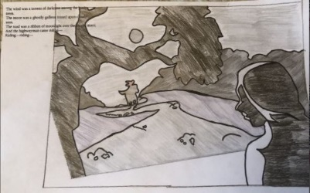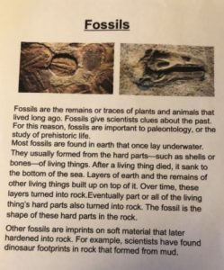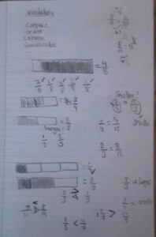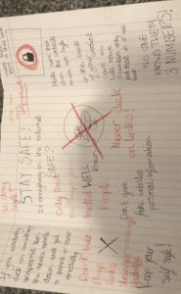 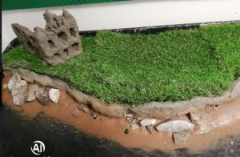
Please keep checking your Class Dojo site for updates about your child’s curriculum and their learning. We celebrate work, which the children have completed weekly, and we welcome your comments.
Thank you again for your support at this difficult time,
Mrs Allingham and Mr Brownsell.

