LI: To multiply unit and non-unit fractions by a whole number.

**I will be successful if…**

|  |  |
| --- | --- |
| I can multiply the whole number by the numerator |  |
| I can represent my answer using a diagram |  |
| I can convert an improper fraction into a mixed number if I need to. |  |

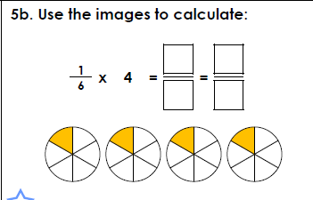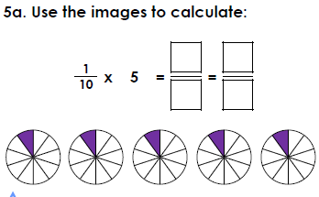

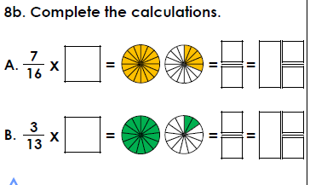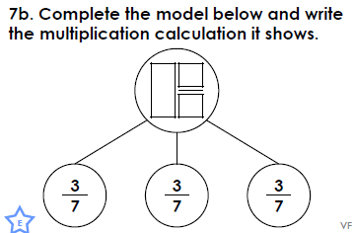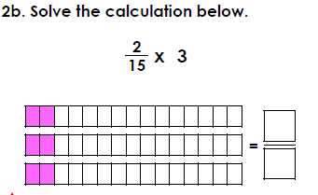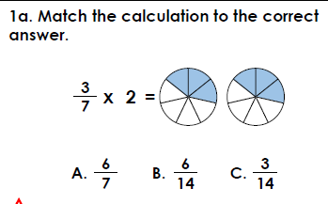

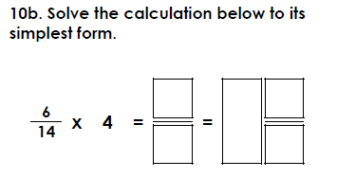**Challenge 1**

**Challenge 2**

