***Challenge***

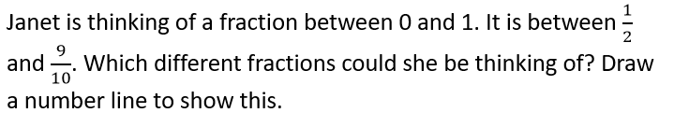

***Challenge***



***Challenge***



***Challenge***

