The Problem
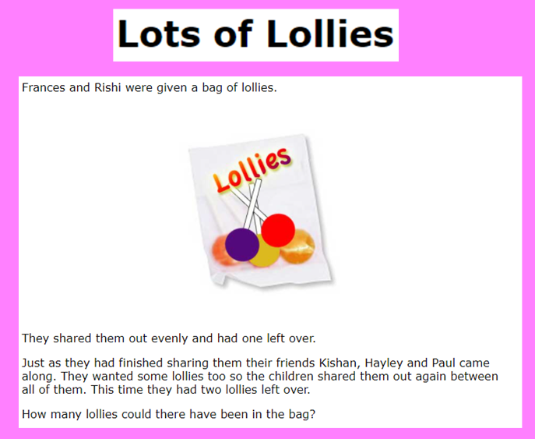
Use the 100-sqaure to record your findings to help you to work systematically to solve this problem. Use the start of the notebook document to give you advice on a starting point.

