5.3.2021
LI: To be able to make different money amounts in a variety of ways.
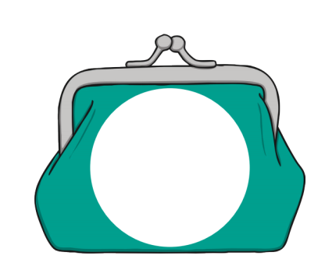
Each person would like 23p. How many different ways could you make 23p?

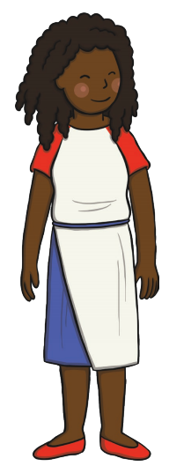

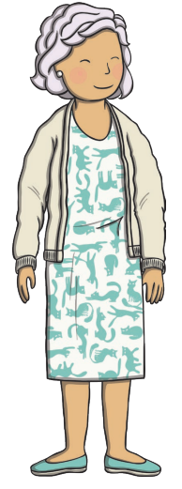

Activity 2: Miss Petty believes that you can make 34p using a 20p coin, a 10p coin, a 3 p coin and 1 p coin. Do you agree or disagree?
___________________________________________________________________________________________________________________________________________________________________________________________________________________________________________________________________________________________________________________________________________________________________________________________________________________________________________________

Challenge:
